*Montage Music Videos: Racial Utopianism vs. Abstract Cowboys*

by

Alan Blanchard

This thesis proposal is submitted in partial fulfillment of

Master of Arts in Liberal Arts, American Studies

Department of Humanities and Cultural Studies

University of South Florida

April 27, 2021

Dr. Todd Jurgess   
Major Professor

Dr. Brook Sadler  
Committee Member

Dr. Andrew Berish  
Committee Member

**Statement of Purpose**

The growth of digital media in the past three decades has been accompanied by a rich, broad genre of “remix” amateur digital media marked by “mashing up” commercial cultural texts to achieve new ends. Since the theories of Ernst Bloch and Richard Dyer suggest utopian impulses in pop-culture texts, I ask what utopian messages are imbedded in remix media as well as what specific remix structures and spectator processes promote their effective transmission. Invoking the film theories of Sergei Eisenstein, the sound theories of Michel Chion, and the music theories of Jennifer Robinson, I suggest a three-step spectator enlightenment process that involves a cognitive shock (step 1) followed by a poetic evolution phase (step 2) and culminating in acceptance of a utopian vision (step 3).

For this investigation, I isolate and define one particular type of remix media – montage music videos – and reveal their utopian impulse for racial harmony. I have chosen two videos from amateur digital media artist DJ Cummerbund. The first is “Old Staind Road,” which is primarily a remix of two commercial music videos: Lil Nas X’s “Old Town Road” and Staind’s “It’s Been Awhile.” This montage music video seeks to evoke empathy for the Other and promote cultural diversity in America. In contrast, the second video, “Blurry in the USA,” remixes a montage music video, composed primarily of Miley Cyrus’ “Party in the USA” and Puddle of Mudd’s “Blurry,” with documentary footage of the 2020 Black Lives Matter protests. Rejecting the spectator enlightenment process, this video seeks to evoke anxiety in spectators to highlight the anempathy in America that must be overcome to achieve multicultural harmony.

Both videos are replete with American cowboy imagery, and I propose a malleable “cowboy masculinity” term to further the analysis in conjunction with Bloch’s concrete and abstract utopia concepts. The cowboy myth in America is strong and has been created by pop-culture texts over the past century. “Blurry in the USA” documents the current dire state of cowboy masculinity with its emphasis on toxic individualism and the cultural stasis of abstract utopia; however, “Old Staind Road” seeks to transform cowboy masculinity by including the Other in a future multicultural concrete utopia. Where commercial analog media created cowboy masculinity, amateur digital media seeks to reform it. While playing a dominant role in the videos, cowboy masculinity also manifests as multifaceted “glitches” with digital, analog, and power meanings. To transform cowboy masculinity and achieve racial harmony, I present the concept of cultural montage and show its roots in Thomas More’s 1519 *Utopia*.

**Original Materials**

While the label “remix” may apply to any digital media which has undergone disassembly and reassembly via software, the genre I find most compelling – and enjoyable – is one I define as Montage Music videos (MMV). My use of the word “montage” is intentional and references the 1920s work of Soviet film scholar Sergei Eisenstein and his theories of montage that I will show directly apply to MMVs. These MMVs are produced and distributed, usually on YouTube, by amateurs who take commercial music videos and blend both the music and the video tracks to create new cultural texts with new meanings. Rather than dismiss these amateur cultural texts as so much digital detritus, I believe they, as direct art products from the masses rather than a proxy thereof, have comparable worth to that of professional artists and deserve academic consideration. I see the present state of remix as not dissimilar to that of film in the middle of the 20th century: a broad category of art with nascent scholarship lacking a well-defined taxonomy. My hope is this thesis will further the analysis of rapidly evolving digital media and its lexicon by demonstrating its relevance to understanding our culture.

For my original materials, I use two MMVs from the oeuvre of DJ Cummerbund (DJC) who has been creating these MMVs, also known colloquially as “mashup” videos, since 2015. In 2020, DJC won a Webby award, which honors the best of the internet, in the Video Remixes/Mashups category for “Play that Funky Music Rammstein.” Since I am interested in utopianism, which according to Ernst Bloch exists in the texts of popular culture, and its tension with the masculinity inherent in the American cowboy myth, I have selected “Old Staind Road” from 2019 as my first MMV. This MMV is replete with cowboy motifs as well as racial utopianism. “Old Staind Road” is composed primarily of the two commercial videos: “It’s Been Awhile” from Staind and “Old Town Road” from Lil Nas X. Two additional videos from Lynyrd Skynyrd (“Simple Man”) and Nirvana (“Heart-Shaped Box”) play lesser but still important roles when it comes to complicating the messy reality of masculinity when compared to the mythical, pristine cowboy ideal.

To explicate the structure of “Old Staind Road” and show its complexity, I identified the video and sound elements in one-second intervals (278 data points for the video’s 4:37 duration) and built a unique color-coded graphic overview of the entire MMV. My inspiration for this objective analysis portion of my thesis comes from the Cinemetrics project which quantified shot duration in films to reveal hidden filmmaking patterns. Below is the graphic I envisioned and built to reveal the structure of this MMV in terms of video, vocals, and music. Using this graphic as well as a close reading of key shots and juxtapositions in the MMV, I will show that “Old Staind Road” is an empathetic video that promotes a vision of Racial Utopianism.

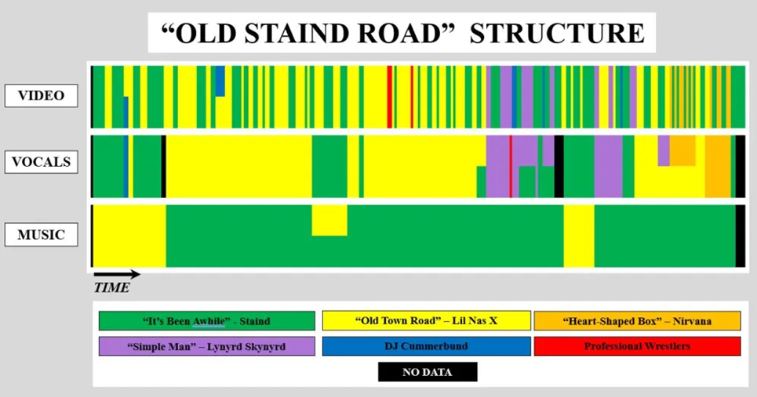

While “Old Staind Road” is an MMV that represents a pure utopian vision without the intrusion of reality, DJC deviated from his standard methodology and introduced documentary elements from the 2020 Black Lives Matter (BLM) protests in his “Blurry in the USA” MMV. This MMV was created and published on 21 Jun 2020 during the height of the BLM protests. These documentary elements override any utopian vision while showing the futility of cowboy masculinity and the anempathetic response of many whites to the plight of African Americans. This anempathy is a term coined by Chion to describe sound/music that is independent and indifferent to video (9). Anempathy is particularly striking when Miley sings and thrusts her “Hands Up” in a carefree, partying sense while the video switches to the BLM protesters putting their “Hands Up” to dramatize the existential terror of blacks stopped by the police and wondering if they will be shot. The most obvious relationship between “Old Staind Road” and “Blurry in the USA” is the real-life father-daughter relationship with Billy Ray Cyrus, featured in the former, and Miley Cyrus, featured in the latter, together representing the familial continuity of American cowboy masculinity and its ability – and necessity – to cross genders. Another link between the two MMVs is the music of Nirvana: Nirvana sings “Heart-Shaped Box” in “Old Staind Road,” and Puddle of Mudd sings an acoustic version of Nirvana’s “About a Girl” in “Blurry in the USA.” The graphic I created to reveal its structure is below.

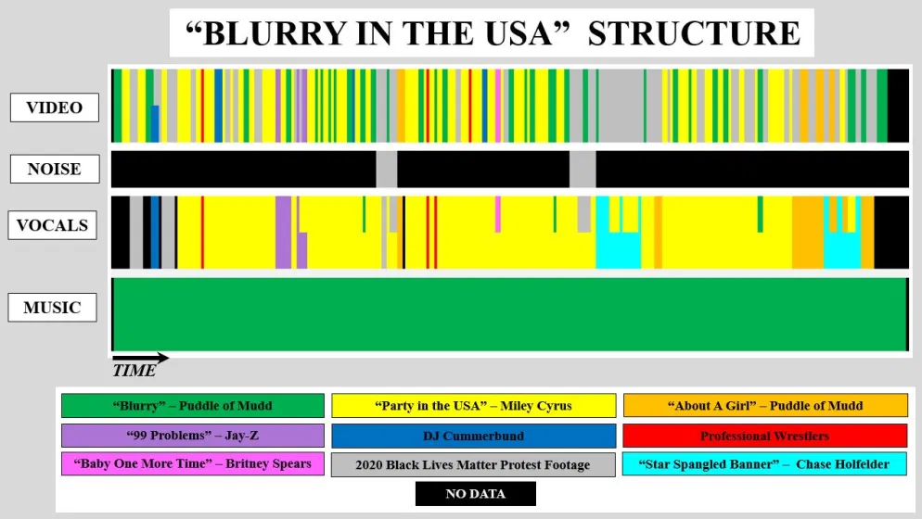

In this thesis, I will show DJC’s MMVs suggest a prerequisite for racial utopianism where the cowboy masculinity that tends to dominate the cultural training of white males in America must be transformed to allow for the blossoming of cultural montage, a state of cultural fluidity where humans are free to respectfully flow from one culture to another thereby trading their usual anempathy (or worse) for the Other to a genuine empathy for all humans. In other words, the key to maximizing humanity and the potential for utopia is to maximize each human’s real and imagined intersectionality. Real intersectionality may be maximized, for example, by DNA testing to reveal one’s true heritage, negating convenient, false hegemonic familial narratives. Imagined intersectionality is another way of evoking empathy and may be created through physical, mental, or digital means, such as experiencing MMVs.

**Contextual Literature**

To understand how MMVs operate, it is essential to understand how sound operates and Michel Chion’s work on the role of sound informs this understanding. As Chion states, the "rapid succession of shots creates a sense of visual polyphony and even simultaneity, even as we see only a single image at a time" (166). In other words, the effect of MMVs is to show, through a montage of differing and rapid shots, a harmonious merging of cultural texts that wouldn't seem likely otherwise. But to ensure the spectator has the greatest chance to properly interpret the visual creation, Chion introduces the concept of "added value" which is the "expressive and informative value with which sound enriches a given image so as to create the definite impression" (5). For Chion, there is ambiguity in the meaning of silent video that "added value" sounds (vocals, noises, music) minimize for spectators. For MMVs, I invert Chion's theory: sound still provides the "definite impression," but visual data provides the "added value" by reducing ambiguity in the music/lyrics. In other words, I challenge the notion that sound plays a subservient role to video at all times: audio-visual media should be thought of as a dance where the lead of sound or video can and will change to effectively impact spectators.

Carol Vernallis, one of the foremost scholars of music videos, puts them in their proper place as complex cultural texts rather than second-thought visual appendages in her book, *Experiencing Music Video: Aesthetics and Cultural Context*. Music videos may be brief in duration when compared to films, but that simply means creative compression is necessary for the artists as well as careful unpacking for the scholars. Vernallis states that “the objective of music video is to be continually engrossing” and that “each shot possesses its own truth” meaning that the spectator is effectively overwhelmed with a rapid success of truths and couldn’t possibly capture it all (15,10). I contend these shots will clash in an Eisensteinian manner; however, Vernallis claims that Soviet “Montage occurs with some frequency in videos, but the collision rarely creates more than a mildly humorous or clever effect” (42). I claim the juxtaposition of shots, consistent with Soviet Montage theory, are more meaningful in MMVs, since MMV artists are intentionally juxtaposing found footage (commercial music videos) as Sergei Eisenstein did. Steven Shaviro finds music videos “complexly overdetermined” and a “hybrid, impure form” that “almost never have the status of independent, self-subsisting works” (7). If music videos themselves can’t reach this status, I argue MMVs can. This happens because MMVs are the work of an individual artist composing a complex audio-visual piece – each shot and juxtaposition has potential meaning. I am in fact treating these MMVs as “self-subsisting works.” Like Vernallis, Shaviro, too, makes mention of Eisenstein stating that “the rapid editing of many music videos bears a formal resemblance to 1920s Soviet montage, but the aesthetic aims of contemporary music video directors…are quite distant from those of…Sergei Eisenstein” (13). This may be true for music videos themselves, but I claim it is not the case for MMVs where the juxtapositions beg for interpretation using 1920s Soviet montage theory as I will do. While music videos may have been created in an analog manner during Shaviro’s “Golden Age of Music Video” (“mid-1980s through the mid-1990s” when MTV played music videos) or digitally in today’s “Second Golden Age” where music videos reside primarily on YouTube, the MMV creations are purely digital products (5, 7). These MMVs are “new media” as Lev Manovich defines it: “graphics, moving images, sounds, shapes, spaces, and texts that have become computable” and have five unique principles: “numerical representation, modularity, automation, variability, and cultural transcoding” (20). I will show how MMVs meet Manovich’s definition of new media by considering MMVs with respect to these five new media principles.

Lindsey Brown's dissertation on new media and mashups helps define the taxonomic and theoretical gap that my thesis is trying to fill when it comes to "mashup" or remix media. Brown does not reference Sergei Eisenstein, and the word montage appears to be used – without an appreciation for its cinematic heritage – as a collection of shots in rapid succession. Brown argues that “vids…use formal juxtaposition to produce alternative ways of seeing and thinking” (15). This is exactly what film scholar Eisenstein proposed a century earlier with his montage theories. Brown states the first “mash up” vid was created in 1975 when music accompanied a Star Trek slide show (21). I propose "the mashup aesthetic" first existed in 1920s Soviet films, and I use Eisenstein's theories to inform the understanding of MMVs. Further, this mashup aesthetic could be seen in later experimental films, such as Bruce Conner's 1958 "found footage" classic, *A Movie*, created from the mashup of short clips from other films set to a classical music soundtrack. This difference of opinion as to what constitutes the broad category of remix media underscores the need to refine the genre to remove confusion. To that end, I propose a subgenre of new media mashup/remix videos that rely on modern software for creation and Soviet montage and other media theories for explanation: Montage Music Videos.

Lawrence Lessig's book, *Remix: Making Art and Commerce Thrive in the Hybrid Economy*, is a seminal work describing the evolution of RO (read only) and RW (read write) cultures stressing the point that RW has always been with us, but the availability of easy-to-use software has enabled the proliferation of remix media also known as hybrid art. In this historical context, MMVs are just another in a long line of remixed creations. In the context of Tim Wu's attention economy, there is an insatiable need for new digital content to direct eyeballs to online ads, and this is where remixing comes in: a cheap, fast way to generate new remixed cultural texts from other digital media. Lessig says that “Remixed media succeed when they show others something new; they fail when they are trite or derivative.” By artfully blending commercial music videos from different genres, MMVs, although they follow a somewhat consistent formula, tend to generate something new and provocative. Since one dominant success metric today is YouTube monetization based on spectator interaction (attention grabbing), no music video, no matter how sacred, is immune to remixing for profit; however, MMVs have been removed from YouTube due to complaints from owners of the original commercial music videos; e.g., DJC's "The Devil Wapped Down the Georgia" (available on YouTube but not on DJC's official site) which remixed Carli B's "WAP" and Charlie Daniel's Band's "The Devil Went Down to Georgia." Since, as Lessig states, remix is essentially nothing new, it is not surprising that film, sound, utopia, and other humanistic theories apply so well to MMVs: it is simply a matter of reorienting the theories to the topography of the new art form.

**Related Literature**

To put my proposed notion of “cultural montage” in the context of utopia, I use Thomas More’s 1519 book *Utopia* as an example to show cultural montage is not a new idea but has been with us for a least 500 years – I’m simply giving it a name. To create his utopian ideal, More starts with a homogeneous population isolated on a protected island with a common religion and bare-bones legal system. These people live either in town or in the country. To ensure an equal distribution of labor, More states that “Out of every one of these families or farms cometh every year into the city twenty persons which have continued two years before in the country. In their place so many fresh be sent thither out of the city” (84). More creates this cycling of folks between town and country to ensure that “no man shall be constrained against his will to continue long in that hard and sharp kind of life” (85). What More calls a “kind of life” in 1519, we would call “culture” in 2021. While I doubt it was intentional, More fortuitously created in his utopia a people with a montage (or blended) culture that reflects both urban and rural sensibilities. More’s people have inherent empathy for both cultures based on first-hand experience – easy to do in a fictional utopia with two cultures, but this montage requires other means in a multicultural nation as diverse as America’s. The importance of More’s implied cultural montage pre-requisite for utopia resonates today in America’s dystopian urban/rural divide, which lacks it, and motivates the quest for fruitful cultural montage experiences in alternative cultural texts such as MMVs.

While cultural montage plays an important role in More’s utopia and in MMVs, to explicate the concept of utopia in more modern terms I invoke the work of world-renowned science-fiction writer Ursula K. Le Guin and her 1982 essay “A Non-Euclidean View of California as a Cold Place to Be.” While she doesn’t explicitly mandate these are the requirements for utopia, Le Guin states that a “society predominantly concerned with preserving its existence” should adhere to four principles: “a society with a modest standard of living, conservative of natural resources, with a low constant fertility rate and a political life based upon consent.” Using our modern “green” language, Le Guin is discussing a society based on sustainability and political freedom. To me, these four requirements are indeed necessary for utopia as violating any one principle can easily result in dystopia.

For centuries, whites and their tyrannical rule of minorities created a racial dystopia for African Americans. Fundamentally, it is the lack of Le Guin’s “political consent” – freedom to choose – that is at the core of racial dystopia. MMVs directly address this by showing the harmonious blending of disparate cultures to remove the fear of the Other and provide a positive future vision – an expansion of Le Guin’s “utopian imagination.” This future is one without racism. Ultimately, MMVs want the Other to exercise their Constitutionally guaranteed, powerful political consent to eliminate America’s racial dystopia. Just like Le Guin’s four utopian principles weren’t explicitly stated as such but the meaning was implied, MMVs make implied racial utopian meaning but use audio-visual form and content rather than written words.

Unlike More’s singular utopia, there are competing visions of utopia in America. Ernst Bloch’s concepts of abstract utopia and concrete utopia help explain the social tension that arises from these differing views particularly when it comes to racial utopianism. Ruth Levitas states that Bloch’s “Abstract utopia is fantastic and compensatory. It is wishful thinking, but the wish is not accompanied by a will to change anything” (15). In this version of utopia, there’s “a future where the world remains as it is except for the dreamer’s changed place in it – perhaps by a large win in a lottery” — it’s essentially immature desire (15). Those who believe in an abstract utopia are those who are generally better off in the social structure to begin with and aren’t concerned with the well-being of Others; i.e., those who benefit from hegemony. They just need money, as Bloch suggests, to make their lives utopian (Levitas, 15). On the other side is concrete utopia which “embodies what Bloch claims as the essential utopian function, that of simultaneously anticipating and affecting the future” and that “only concrete utopia carries hope” (Levitas, 15). Bloch puts it another way: abstract utopia has a “tendency to become lost in fantasy and memory” while concrete utopia is “oriented to real possibility” for the future (Levitas, 15).

I view Bloch’s concrete and abstract utopias through Le Guin’s “consent” requirement lens and position them in our modern remix culture to create two competing utopian visions operating in America and in MMVs: Racial Utopianism and Cowboy Masculinity. Abstract utopia has no interest in change – it’s backward looking, selfish, myopic, and inspired only by a fantasy of how things were in the past. Concrete utopia is forward looking, wants a better future for all, and expects change. I then extrapolate these utopian concepts, blend them with Le Guin’s requirement for consent in a sustainable utopia, and find suitable binaries for remixed media and cultural montage. Thus, I have created two categories of utopia based on Bloch’s concepts that are applicable to the racial overtones and cowboy motifs prevalent in the MMVs under investigation: Racial Utopianism and Cowboy Masculinity. Because it prioritizes a new vision for society, Racial Utopianism embraces change, remixing cultural texts (especially hegemonic histories), and cultural montage that will result in empathy and consent for all. On the other hand, Cowboy Masculinity wants no change in society and will fight those who dare alter their hegemonic culture. Generally speaking, “Old Staind Road” is an affirmation of Racial Utopianism, and “Blurry in the USA” is a critique of Cowboy Masculinity. Despite the seemingly lost cause that is Cowboy Masculinity, there are suggestions in the MMVs that it may be reformed: the American Cowboy is too powerful a cultural symbol to simply toss when the possibility exists that it may be transformed into a force for good.

**Theoretical Literature**

I propose MMVs function in a three-step process to enlighten spectators: 1) abrupt juxtapositions - shocks - inspired by the montage theories of Sergei Eisenstein, 2) a relatively long poetic evolution phase inspired by the music appreciation work of Jenefer Robinson, and 3) utopianism inspired by the popular entertainment analyses of Richard Dyer. To visualize this process, I begin with the simple Eisenstein drawing that Luka Arsenjuk presents below.

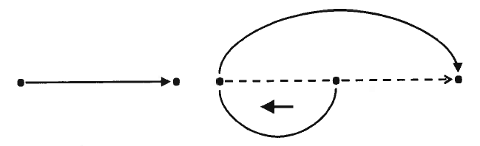

I have added notation to Eisenstein’s drawing to show the difference between the typical "logical pair" process that Eisenstein describes, Eisenstein's "Dynamic Triad," and the MMV process I propose as shown below. These are three mechanisms for what I call “spectator enlightenment.”

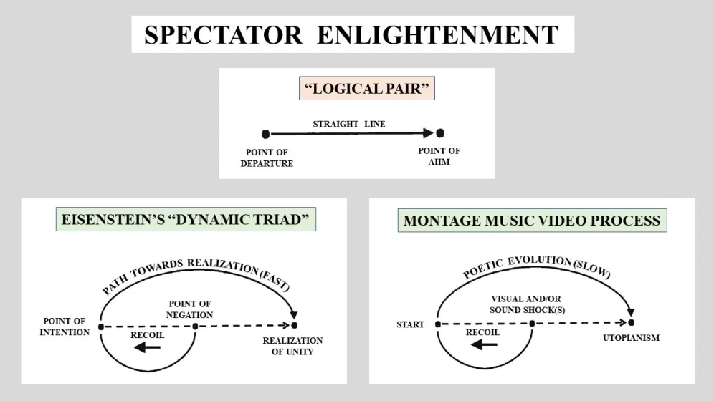

The “logical pair” process is typical and generally assumes spectators will “get” the filmmaker’s aim simply by viewing the film: there’s a straight line between the “point of departure” (starting to view a film) and the “point of aim.” Eisenstein thought an effective process was more complex and that a “negation of negation” was necessary to truly impact the spectator and ensure it as “something concrete” (Arsenjuk, 6, 7). The first negation in Eisenstein’s Dynamic Triad, the “point of negation,” is a shock that causes the spectator to recoil from the juxtaposition presented and go in a direction opposite to that the filmmaker desires. These shocks transformed the spectator from a passive receiver of information to an active participant in the generation of information. The second negation – the “negation of negation” – is the return to forward motion, the “path towards realization,” in a circuitous manner that leads to the “realization of unity,” the filmmaker’s “point of aim” for the spectator. The MMV process also assumes shocks that recoil the spectator; however, rather than the instantaneous realization of something new in the minds of spectators that Eisenstein assumed for his engineered juxtapositions, the MMV process I propose assumes a lengthy “poetic evolution” stage that leads to a sense of utopianism. This notion of MMV utopianism isn’t that far from Eisenstein’s thinking. Arsenjuk states that “Eisenstein’s idea of cinema is that of a grand synthesizing machine capable of securing a new relation of the unities of art, subjectivity, and collective or historical humanity” and “a place for thinking the historical unity of humanity engaged in the process of overcoming its alienated existence” (6). In other words, films to Eisenstein were a way to enhance our humanity and relieve alienation by presenting de facto utopian ideas to achieve those goals.

The first step in MMVs is the intentional infliction of shock in the audience by the juxtaposition – the montage – of two unexpected images, sounds, or both simultaneously. This juxtaposition is the fundamental concept of cinema theorized by Sergei Eisenstein during the Soviet Montage era in the 1920s. According to Eisenstein, there are five types of montage: metric, rhythmic, tonal (melodic), overtonal, and intellectual (228). The focus of MMVs is on the intellectual type of montage where “from the juxtaposition of two given factors we observed the emergence of a third: a new one which does not coincide with either of its two constituents and which introduces a new quality, a new connotative dimension” (Eisenstein 273). Montage was not simply about cutting and pasting film together, but was a “a very advanced conception of…breaking down a phenomenon “as such” and recombining it into something qualitatively new, into a view of an attitude towards a phenomenon that is a socially interpreted generalization about it” (Eisenstein 247). The intentions of these clashes were to generate specific, engineered ideas in the minds of spectators that played upon their cultural training; e.g., the image of an old man’s face followed by a child in a casket would generate a sense of sadness in spectators who would link the two images together to make sense of the juxtaposition. But Eisenstein was not interested in such trivial meanings, he wanted montage to inspire social thought and commentary on society – in his case, revealing to the masses that the Tsar was no supporter of theirs. Likewise, MMVs aspire to instill new social thoughts in spectators by first introducing culture clashes that intentionally produce shock and perhaps other negative thoughts. For the culture clashes in MMVs to work, one must identify with and be invested in one of the cultures that are being blended. Although the MMV process begins with shocking spectators, its ultimate goal is to evoke a sense of harmony in their minds between the two cultures.

This sense of cultural harmony could easily be seen as an element of what Richard Dyer referred to as utopianism, “the sense that things could be better, that something other than what is can be imagined and maybe realized” (273). Dyer was making the case that so-called popular entertainment reveals the deep desires of its consumers for a better world in that “entertainment offers the image of ‘something better’ to escape into, or something we want deeply that our day-to-day lives don’t provide” (273). For his analysis, Dyer focuses on Hollywood musicals which due to their “relatively high proportion of non-narrative moments” and songs are closely related to the modern music video (271). Dyer argues that the film industry meets the “real needs” of spectators for “a different and better social order” by “picturing relations between people more simply and directly” and/or using “music, color, and movement” (271). In other words, the pleasing visual and sonic harmony in Hollywood musicals directly reflects for Dyer the spectators’ desire for social harmony implicit in a “better social order.” This is also the goal of MMVs, but because they are based on at least two cultures initially clashing there is the understanding that either one or perhaps both of the cultures haven’t yet envisioned the ‘something better’ or utopianism that MMVs allude. A significant difference between Dyer’s Hollywood musicals and MMVs is their intended audience: musicals are primarily intended for the enjoyment/escape of counter-hegemonies with an indirect reference to a better social order, but MMVs challenge hegemonies directly to accept a named Other to create Dyer’s better social order. Indeed, the utopianism manifest in MMVs, the Racial Utopianism described earlier, provides a literal and figurative vision of the future that, if done well, can assuage the undeniable fear of change.

To get from Eisenstein’s shocking juxtapositions in MMVs to Dyer’s utopianism is no trivial feat and involves a process I call poetic evolution informed by Jenefer Robinson’s work on the aesthetic appreciation of music. Robinson defines four ways that music can invoke emotions in listeners: culture, appreciation, structure, and mimesis (655-7). Both structure and appreciation elements are relevant to MMVs. Structure depends on the expectations of the listeners as the work develops. According to Robinson, “all these emotions – surprise, satisfaction, bewilderment, relief, puzzlement, unsettledness, and so on – are emotions that are the result of appraising how the music is developing” (656). In other words, “how we appraise the development of the music depends on the expectations we have as we listen” (Robinson 656). While MMVs start with a shock by design, obviously not meeting the expectations of the spectators, the intellectual result is at best surprise and at worst some other negative emotion like anger or disgust. The key to modifying the spectators’ future expectations and generating positive emotions (essential for Dyer’s utopianism) involves the second element: appreciation – this is the chance for the artist to win over the audience by sheer craftsmanship. After the initial shock(s), the artist has the attention of the spectators and must now seamlessly blend the cultural elements together in a manner that results in the spectators developing an appreciation of the work resulting in the transformation of cultural clashes from sources of discomfort (at the beginning of the work) to sources of pleasure and acceptance (at the end of the work). This must happen if MMVs are to be successful in presenting a future vision that not only removes the fear of the future and its cultural change but also makes the future desirable and favored over the present status quo.

While the overall MMV process may be assessed using the 3-step approach outlined above, for a more detailed analysis of the interplay between sound and video additional terminology and theories are required. In general, there are three ways that sound and video interact in the creation of meaning: when they reinforce each other, when they conflict, and when they are indifferent. Sounds may include dialog, noises, and music. Since MMVs are primarily music first, I’ll use sound scholar Michel Chion’s term “empathetic” for music that “can directly express the scene’s rhythm, tone, and phrasing; obviously such music participates in cultural codes for things like sadness, happiness, and movement” (8). Thus, empathetic music reinforces the video image and does much cultural and emotional work. The term “code” is interesting in that it has another meaning relevant to MMVs and digital media in general: algorithms. “Mickeymousing” is another closely related term that describes “visual action in synchrony with musical trajectories (rising, falling, zigzagging) and instrumental punctuations of action (blows, falls, doors closing)” (Chion, 121-2). For my analysis, I will usually use the term “mickeymousing” for very short duration elements of video coinciding with lyrics dictating the action where emotions tend not to play a role. For the case where there is a “conflict between optical and acoustical experience,” Eisenstein coins the term “audio-visual counterpoint” but the shortened “counterpoint” will be used (Film Form, 54-55). James Buhler and David Neumeyer define the effect on spectators due to counterpoint in two ways: 1) humor when there is a “failure of temporal synchronizing or image track and sound track elements,” and 2) “an emotional distance of sound from image” that leads to “defamiliarization” (81). In MMVs, the artists take much care to ensure that temporal synchronization is as flawless as possible, so the primary counterpoint effect on spectators will be defamiliarization and the slight anxiety it produces. For a more intense emotional response in spectators, Chion coins the term “anempathetic” where there is a “cosmic indifference” between music and the video and the “juxtaposition of scene with indifferent music has the effect not of freezing emotion but rather of intensifying it” (8). Further, anempathetic effects can be produced in spectators using noises as well (Chion, 9). With both anempathetic sound and noises, the audio track proceeds without ever acknowledging the typically dramatic scenes in the video track.

To show how the MMV process works in “Old Staind Road” and how it intentionally does not in “Blurry in the USA,” I will conduct a close reading of specific segments, image juxtapositions, and imagery from the MMVs. I will use film analysis techniques such as mickey mousing, graphic matching, Soviet Montage, and eyeline matching to show how harmony/discord and meaning is created.

**Organization**

1. Introduction
   1. Statement of Purpose
   2. Overview of Thesis structure
2. Analog, Digital, and Montage Music Videos
   1. Discuss Music Videos (Vernallis)
   2. Discuss of Digital Media (Manovich, Shaviro)
   3. Define “Montage Music Video”
   4. Economic Context for MMVs (Wu)
3. Overview of “Old Staind Road” and “Blurry in the USA”
   1. Overview of DJC and his work
      1. DJC’s Oeuvre
      2. 2020 Webby Award
      3. Summary of April 2020 correspondence with DJC
   2. “Old Staind Road”
      1. Description
      2. Structure (objective, distant reading)
      3. Lyrics
   3. “Blurry in the USA”
      1. Description
      2. Structure (objective, distant reading)
      3. Lyrics
      4. Documentary “poetic mode”
   4. Thumbnail Analysis
4. Cultural Montage and Utopia
   1. Discuss More’s *Utopia*
   2. Discuss Le Guin’s 4 requirements for Utopia
   3. Discuss Bloch’s Abstract & Concrete Utopia
   4. Define “Racial Utopianism” and “Cowboy Masculinity”
   5. Discuss Masculinity
      1. Masculinity & Toxic Masculinity
      2. The Cowboy Myth
      3. “Cowboy Masculinity” as an opportunity
5. The Montage Music Video Process for Spectator Enlightenment
   1. Eisenstein’s “Logical Pair” and “Dynamic Triad”
   2. Montage Music Video 3-Step Process
      1. Step 1: Shock
      2. Step 3: Utopianism
      3. Step 2: Poetic evolution
      4. The role of sound (Chion)
6. The Initial Shock: Step 1 of the MMV Process
   1. Productive Shock in “Old Staind Road” (close reading)
      1. Audio/visual Set up for shock
      2. Analysis of Shock itself
   2. Fruitless Shock in “Blurry in the USA” (close reading)
      1. Audio/visual Set up for shock
      2. Analysis of Shock itself
7. Poetic Evolution: Step 2 of the MMV Process
   1. Effective Poetic Evolution in “Old Staind Road”
      1. Analysis of MMV structure using color-coded graphic
      2. Close reading (eyeline matching, graphic matching, juxtapositions, etc.)
   2. Intentional Rejection of Poetic Evolution in “Blurry in the USA”
      1. Analysis of MMV structure using color-coded graphic
      2. Close reading (eyeline matching, graphic matching, juxtapositions, etc.)
8. Utopianism: Step 3 of the MMV Process
   1. Racial Utopianism in “Old Staind Road”
      1. Close reading
      2. Masculinity redefined: “Empathy, Care, & Fun”
      3. Epilogue – a rational appeal to spectators to embrace Racial Utopianism
   2. Dystopian Cowboy Masculinity in “Blurry in the USA”
      1. Close reading
      2. Epilogue – an emotional appeal to spectators to reject Cowboy Masculinity
9. Cultural Montage
   1. MMV Process is a subset of the more general “Cultural Montage”
   2. The “Edge Effect” from ecology – analog for cultural montage
   3. Cultural Montage in Art compared to “Culture Shock”
   4. Brief Historical examples from Pop Culture of effective cultural montage
   5. The Danger: Fruitless Shocks without Poetic Evolution (ex. “Piss Christ”)
   6. Value of Cultural Montage
      1. Change Management
      2. Pedagogy
   7. Cultural Montage and Cultural Appropriation
   8. The Inevitability of Glitches
      1. How they manifest in DJC’s work (sight, sound, duration)
      2. What they mean for the artist, MMVs, and Cultural Montage
10. Conclusion (cultural montage is as scalable as a fractal)

**Preliminary Bibliography**

Arsenjuk, Luka. *Movement, Action, Image, Montage: Sergei Eisenstein and the Cinema in Crisis*. University of Minnesota Press, 2018.

Brown, Lyndsay. “Generation through Appropriation: New Media and the Mashup Aesthetic.” Dissertation Abstracts International Section A: Humanities and Social Sciences, vol. 79, no. 2–A(E), ProQuest Information & Learning, 2018.

Buhler, James and David Neumeyer. *Hearing the Movies: Music and Sound in Film History*. Oxford, 2016.

Chion, Michel. *Audio-Visual: Sound on Screen*. Columbia University Press, 1994.

Conner, Bruce, director. *A Movie*, 1958

DJ Cummerbund. “Blurry In The USA.” YouTube, 21 Jun 2020, https://www.youtube.com/watch?v=-MB_X53mexY. Accessed 17 Jul 2020.

DJ Cummerbund, “Old Staind Road,” YouTube, 5 Jul 2019, https://www.youtube.com/watch?v=xTKlizBS9eA. Accessed 12 Jul 2019.

Dyer, Richard. *Only Entertainment*. Routledge, 1992.

Eisenstein, Sergei. *Film Form: Essays in Film Theory*. Harcourt Brace, 1977.

Eisenstein, Sergei. *Selected Works: Volume 2 Towards a Theory of Montage*. British Film Institute, 1991.

Fitzpatrick, Meagan. “Why Ted Cruz read Green Eggs and Ham in the U.S. Senate.” CBC-Radio Canada, 25 Sep 2013. https://www.cbc.ca/news/world/why-ted-cruz-read-green-eggs-and-ham-in-the-u-s-senate-1.1867499. Accessed 1 Apr 2021.

Le Guin, Ursula K. “A Non-Euclidean View of California as a Cold Place to Be (1982).” *The Fifth Estate*, www.fifthestate.org/archive/382-spring-2010/non-euclidean-view-california-cold-place-1982. Accessed 20 Feb 2021.

Lessig, Lawrence. *Remix: Making Art and Commerce Thrive in the Hybrid Economy*. Penguin Press, 2008.

Levitas, Ruth. “Educated Hope: Ernst Bloch on Abstract and Concrete Utopia.” *Utopian Studies*, vol. 1, no. 2, Dec. 1990, pp. 13-26.

Manovich, Lev. *The Language of New Media*. MIT Press, 2001.

More, Thomas, Saint, 1478-1535., et al. *Sir Thomas More, the Utopia*. London, G. Routledge & sons ltd.; New York, E. P. Dutton & co., 1925.

Pearce, Matt. “At least four Marlboro Men have died of smoking-related diseases.” The Los Angeles Times, 27 Jan 2014. https://www.latimes.com/nation/nationnow/la-na-nn-marlboro-men-20140127-story.html. Accessed 30 Mar 2021.

Robinson, Jenefer. “Emotional Responses to Music: What are they? How do they work? And are they relevant to aesthetic appreciation?” The Oxford Handbook of Philosophy of Emotion, edited by Peter Goldie, Oxford University Press, 2010, pp.651-680.

Shaviro, Steven. *Digital Music Videos*. Rutgers University Press, 2017.

Vernallis, Carol. *Experiencing Music Video: Aesthetics and Cultural Context*. Columbia University Press, 2004.

Wu, Tim. *The Attention Merchants: The Epic Scramble to Get Inside Our Heads*. Knopf, 2016.

**Additional Sources Under Review**

Austerlitz, Saul. *Money for Nothing: A History of the Music Video From the Beatles to the White Stripes*. Continuum, 2007.

Brackett, David. *Categorizing Sound: Genre and Twentieth-Century Popular Music*. University of California Press, 2016. (Chap. 8 “Crossover Dreams”)

Connell, R.W. *Masculinities*. University of California Press, 1995.

Dary, David. *Cowboy Culture: A Saga of Five Centuries*. University Press of Kansas, 1989.

Dauw, Esther and Daniel Connell, editors. *Toxic Masculinity: Mapping the Monstrous in our Heroes*. University Press of Mississippi, 2020. Kalinak, Kathryn. *Film Music: A Very Short Introduction*. Oxford, 2010.

Eisenstein, Sergei. *The Film Sense*. Harcourt Brace, 1970.

Eyman, Douglas. *Digital Rhetoric: Theory, Method, Practice*. University of Michigan Press, 2015.

Gilmore, David. *Manhood in the Making: Cultural Concepts of Masculinity*. Yale, 1990.

Kimmel, Michael. *Manhood in America: A Cultural History*. The Free Press, 1996.

Korsgaard, Mathias. *Music Video After MTV: Audiovisual Studies*, New Media, and Popular Music. Routledge, 2017.

Messerschmidt, James. *Hegemonic Masculinity: Formulation, Reformulation, and Amplification*. Rowman & Littlefield, 2018.

Nesbet, Anne. *Savage Junctures: Sergei Eisenstein and the Shape of Thinking*. I. B. Tauris, 2003.

Railton, Diane and Paul Watson. *Music Video and the Politics of Representation*. Edinburgh University Press, 2011.

Robertson, Robert. *Eisenstein on the Audiovisual: The Montage of Music, Image and Sound in Cinema*. I. B. Tauris, 2011.

Zuckerman, Ethan. *Rewire: Digital Cosmopolitans in the Age of Connection*. Norton, 2013.